**[39] Design DFA Which Accepts String ABBAABABC Over {A,B,C}**

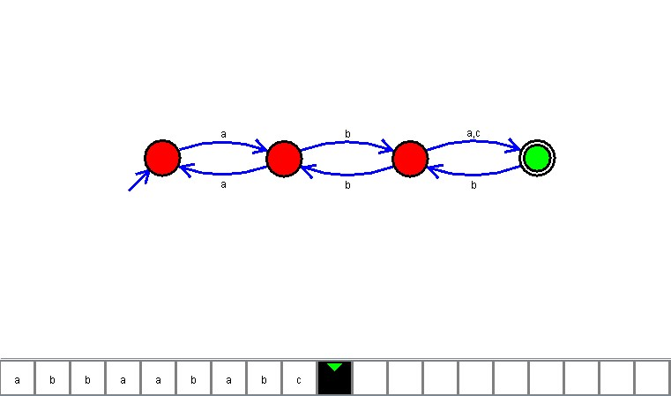

**Result**

The DFA is designed to compute the strings given as input using the Automaton Simulator